
RAMAIAH
Institute of Technology
USN | 1 | M | S

(Autonomous Institute, Affiliated to VTU)
(Approved by AICTE, New Delhi & Govt. of Karnataka) Accredited by NBA & NAAC with ‘A+’ Grade

EXAMINATIONS SEPTEMBER /OCTOBER 2021
SUPPLEMENTARY SEMESTER / GRADE IMPROVEMENT/ RE –REGISTERED CANDIDATES
Program | : | B.E. : Electrical and Electronics Engineering | Semester | : | V
Course Name | : | Power System Engineering - I | Max. Marks | : | 100
Course Code | : | EE53 | Duration | : | 3 Hrs

Instructions to the Candidates:
- Answer any five full questions.

1. | a) |  | With neat sketch explain a typical transmission and distribution systems. | CO1 | (06)
 | b) |  | Briefly discuss the different types of supporting structures, which are used for overhead transmission lines. | CO1 | (06)
 | c) |  | With the help of phasor diagram, discuss the AC distribution when power factors referred to respective load voltages. | CO3 | (08)
2. | a) |  | The two towers of height 95m and 70m respectively support the line conductor at a river crossing. The horizontal distance between the towers is 400m. If the tension in the conductor is 1100kg and its weight is 0.80 kg/m, find (i) sag at lower support (ii) sag at lower support (iii) the clearance of lowest point on trajectory from water level. Assume bases of towers to be at the water level. | CO1 | (10)
 | b) |  | Explain AC distribution systems in brief. A single phase AC distributor AB 200 m long is fed from end A and is loaded as under:  (i) 50 A at 0·8 p.f. lagging 100 m from point A  (ii) 100 A at 0·707 p.f. lagging 200 m from point A  The load resistance and reactance of the distributor is 0·3 Ω and 0·2 Ω per kilometer. Calculate the total voltage drop in the distributor. | CO3 | (10)
3. | a) |  | A single 3-phase line operated at 50Hz is arranged as equilaterally spaced with 2m, 2m and 3m sides. The conductor diameter is 0.6 cm. Find the inductance and capacitance per/km. The line is regularly transposed. | CO2 | (10)
 | b) |  | Explain the voltage distribution over a string of suspension insulators. Also define string efficiency. | CO4 | (10)
4. | a) |  | Discuss the effect of earth on the capacitance of transmission lines. | CO2 | (06)
 | b) |  | A three-phase transmission line has symmetrically spaced conductors having diameter of 2cm each. The spacing between conductors is 1m. The line is overhead line. Compute capacitance per phase per kilometer. | CO2 | (08)
 | c) |  | Briefly explain composite insulators. | CO4 | (06)
5. | a) |  | Write short notes on i) advantages of underground cables over overhead lines ii) grading of cable. | CO4 | (10)
 | b) |  | List out any four advantages of per unit representation. A 120MVA, 19.5kV, generator has Xs= 1.5pu and is connected to a transmission line by a transformer rated 150MVA, 230Y/18ΔkV with X=0.1pu. If the base to be used in the calculation is 100MVA, 230kV, for the transmission line, find the per unit values to be used for the transformer and generator reactance’s. | CO5 | (10)
6. | a) |  | A 3 core 3phase metal sheathed cable on testing for the capacitance gave the following results. Capacitance between all conductors bunched and sheath equals 0.6µF. Capacitance between two conductors bunched with shield and third conductor equals 0.36µF. With the sheath insulated find i) capacitance between any two conductors ii) capacitance to neutral. | CO4 | (10)
 | b) |  | Determine ABCD constants for a 3 phase 50Hz transmission line 200km long having the following distributed parameters.  Inductance/km, l=1.3x10⁻³, capacitance/km, c=9x10⁻⁹F/km, resistance/km r=0.20Ω/km. Assume conductance/km, g=0. | CO2 | (10)
7. | a) |  | Explain the zero sequence equivalent circuits of three phase transformer banks with symbols of one line diagrams. | CO6 | (10)
 | b) |  | Obtain the sequence network representing a line-to-line fault on an unloaded generator. | CO6 | (10)
8. | a) |  | Obtain the sequence networks of an unloaded three phase star connected generator grounded through a reactor. | CO6 | (10)
 | b) |  | Explain the concept of symmetrical components in analyzing unbalanced AC systems. | CO6 | (10)
9. |  | a) | A synchronous generator and motor rated 30MVA, 13.2kV and both have sub-transient reactance of 20%. The line connecting them has a reactance of 10% on the base of the machine ratings. The motor is drawing 20MW at 0.8 pf leading. The terminal voltage of the motor is 12.8kV. When a symmetrical 3 phase fault occurs at the motor terminals at p, find the sub-transient current in generator, motor and at the fault point. The equivalent circuit is shown in Fig. 9(a). Choose generator ratings as the base.  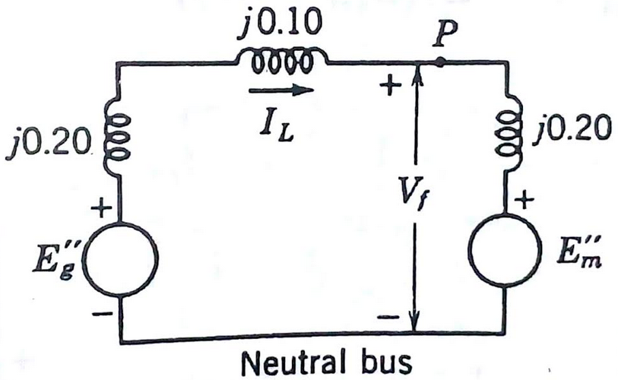  Fig.9 (a) | CO5 | (12)
 |  | b) | A salient pole generator rated 20MVA, 13.8kV, with X₁= 0.25pu, X₂= 0.35pu and X₀=0.1pu. The neutral of the generator is solidly grounded. Determine the sub-transient current in the generator and the line to line voltages for sub-transient condition when an L-G fault occurs at the generator terminal with the generator operating at rated voltage. Neglect resistance. | CO6 | (08)
10. |  | a) | Draw and explain the interconnection of sequence networks in case of i) line to ground fault ii) double line to ground fault. | CO6 | (12)
 |  | b) | A salient pole generator rated 20MVA, 13.8kV, with X₁= 0.25pu, X₂= 0.35pu and X₀=0.1pu. The neutral of the generator is solidly grounded. Determine the sub-transient current in the generator and the line to line voltages for sub-transient condition when an L-L fault occurs on phases b and c at the generator terminal with the generator operating at rated voltage. Neglect resistance. | CO6 | (08)

****************

